Your Probus Club

Meets on the which day of the month

At Meeting Place and address

For its general meeting.

Time: starting time start

and is a type of club club.

PLEASE TELL ME MORE

I would like to know more about Probus

Name:

Address:

Telephone:

E-mail address:

PLEASE SEND TO:

The Secretary

Your Probus Club

Mailing Address

Suburb QLD Postcode

Or telephone: Secretary Phone Number

Or e-mail: club email address



* PROBUS is NOT a fundraising organisation
* PROBUS exists to provide a social forum, fellowship and friendship for like-minded people
* PROBUS is not affiliated to a central organising body
* Each PROBUS Club sets its own rules
* The origins of PROBUS were with Rotary, who sponsored the first clubs
* PROBUS Clubs may be combined or mixed gender, men only or women only
* There are no upper or lower age limits.

Your Probus Club is an affiliated member of the Probus Association of Queensland



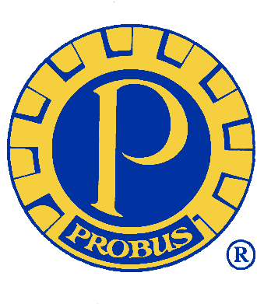

WHAT IS PROBUS?

WHO ARE ITS MEMBERS?

WHAT DOES IT DO?

CAN I JOIN?

HOW DO I FIND OUT MORE?



Your Probus Club

can be contacted by calling the

Club Secretary, Secretary Name,

on Secretary Phone

Find out more about Probus by visiting:

[www.probussouthpacific.org](http://www.probussouthpacific.org)

New Friends in Retirement

Meet new friends, explore new places, discover new interests with bus trips and social outings or just enjoy the company of other retirees and listen to a guest speaker at the regular monthly meeting. local outings, interstate trips and even international travel will provide additional stimulus and experiences.



Fellowship and Fun

Probus clubs have activity groups for members to engage in depending on their own lifestyle and interests. Activities may include walking, bike-riding, dining out, craft, Scrabble, Mah Jong, book clubs, photography and computer skills. These activity groups increase the fellowship, friendships and fun

within Probus clubs and between their members.



Why Not Join Today?

Probus clubs are non-fund-raising and there are more than 150 clubs throughout Queensland with a

membership in excess of 10,000. Probus is for all retired and semiretired people over 55. For more

information on your nearest Probus club please call the Probus Association of Queensland on 0477000645 or visit the Probus Association of Queensland website at [www.paqnetwork.com.au](http://www.paqnetwork.com.au)

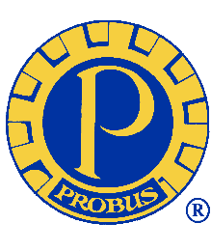

WHAT IS PROBUS?

A PROBUS Club is a local association of retired and semi-retired people who have had some measure of responsibility in any field of worthy endeavour, who are of character and respected in their communities.

Clubs meet regularly for fellowship and to provide regular opportunities for them to keep their minds active, expand their interests, and try to enjoy the fellowship of new friends.

Our focus is on***:” Fun, Friendship, and Fellowship***.”

Each club is autonomous and chooses its own rules and programme. Some clubs meet weekly, some monthly, some twice a month. Some have coffee mornings with guest speakers, some have lunches or dinners. Many organise day trips and holidays to which partners and friends may be invited if the club so chooses.

Each club elects its own officers, typically a president, vice-president, secretary, treasurer, speaker-finder and membership secretary.

PROBUS Clubs do not exist to raise money for charity, although some choose to run occasional fund-raising events and raffles for the benefit of their members.

 

PROBUS SUPPORT

The Probus Association of Queensland has a magazine published quarterly and designed as a forum for clubs to share experiences and seek or impart advice. The magazines are free to all PAQ affiliated clubs.

 

Probus South Pacific produce the Active Retirees magazine which is the only publication published nationally for Probus members.

PROBUS clubs in Australia also now have an ‘umbrella’ website: [www.probussouthpacific.org](http://www.probussouthpacific.org).